Administrator Guide
jWebSocket
Ping Pong Game <1.0>

Author?

Versioncontrol?

- Process application download
To install this application it is necessary to download jWebSocket client and server packages. The application is available for download at the following address:
http://jwebsocket.org/downloads .
Packages | Size
Ping Pong Game Server | 387 Kb
Ping Pong Game Client | 767 Kb

- Features of the installation environment.
You need a server on which is mounted the database application.
How to unpack the zip archives, to which location? How to start the server?

- Installation process.
If the operating system is Linux, the package that contains the application client must be copied var/wwwIn addition it should be given all permits through the console. The package that contains the server can be stored in any location. Before running the client in the browser, the server must be running on an IDE.
If the operating system is Windows, you must have installed Wamp that creates the folder C://wamp/www. In this folder you must copy the packet that containing the client. The package that contains the server can be stored in any location. Before running the client in the browser, the server must be running on an IDE.
To install the Wamp must take the following steps:

Step 1: Open Wamp installer and click Next.
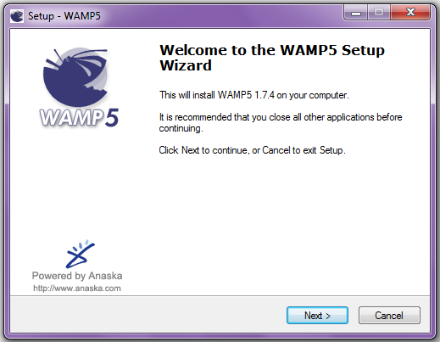
Step 2: Accept the license terms and click Next.
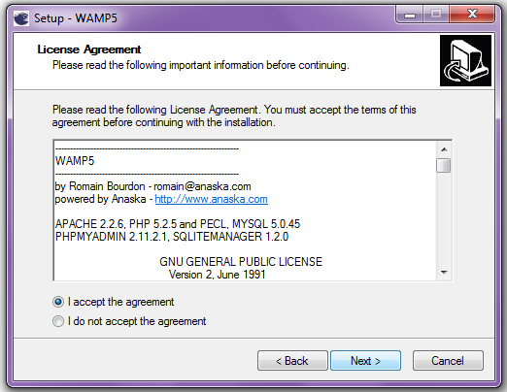
Step 3: Select the destination location where it will be installed Wamp and click Next.
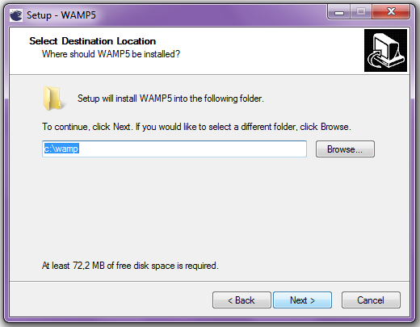
Step 4: Select the Wamp folder that will appear in the Start menu and click Next.
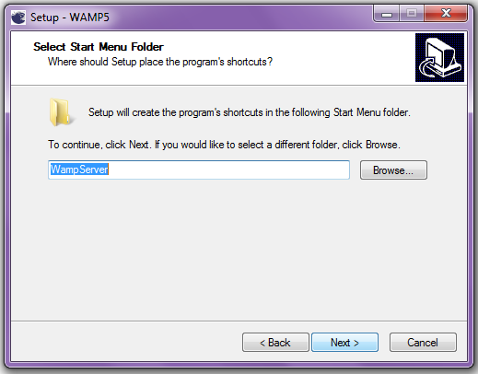
Step 5: Decide whether Wamp will be initiated to load the operating system or will be start manually when the user wants and click Next.
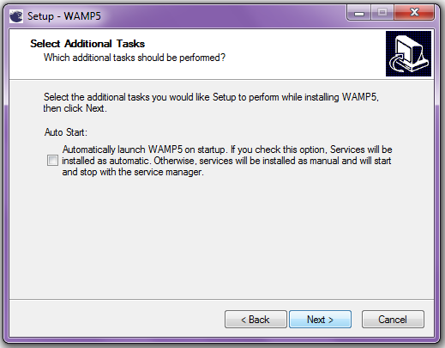
Step 6: Click on Install.
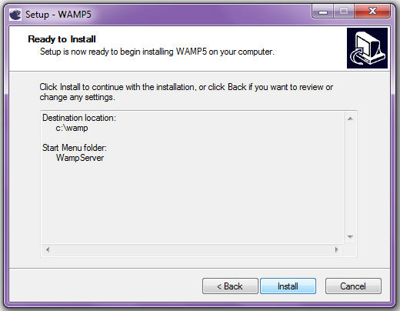
Step 7: Select the directory for the DocumentRoot and click “Aceptar”.
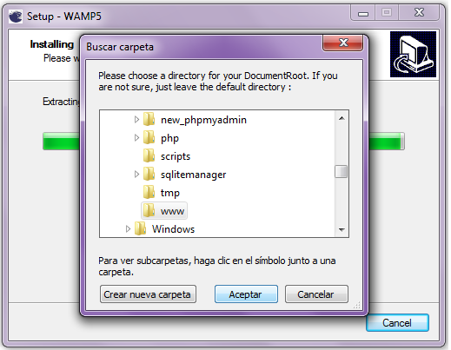
Step 8: Define the name for the SMTP server and click Next.
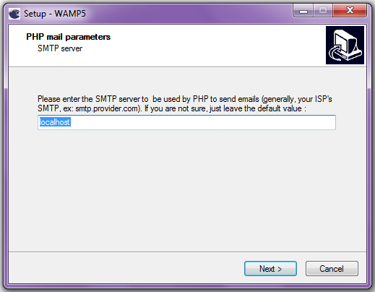
Step 9: Enter the email address to which PHP will send emails.
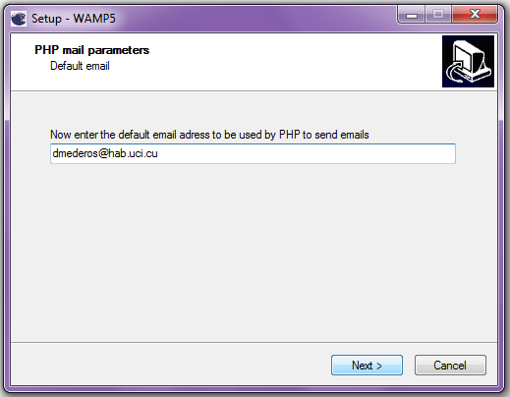
Step 10: Select the browser that will use WAMP and to click “Si”.
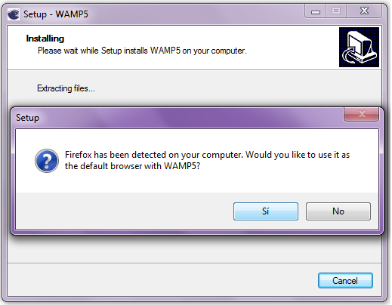
Step 11: Finish the installation by clicking Finish.
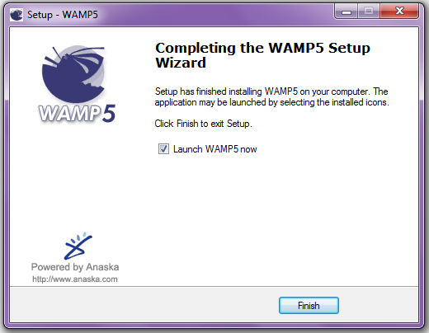

3.1 Hardware's application
The application does not use any additional hardware to operate.
4. Configuration Options
No need for any configuration for the application execution. ¿What about the plug-in section in the jWebSocket.xml?

5. Commissioning
To run the application should start the server How? Where to find? and then open jWebSocket client Ping Pong Game in any of the browsers that support WebSocket. URL? What to configure for that in WAMP’s httpd.conf to get that running? Also must be up and running the database server.
After this if the user has an account created only has to authenticate himself to start interacting with the application, but must register.

6. Application Management
Management of Ping Pong Game can be supported in the user manual.
In the event of any problems during installation of the application, contact:
Alexander Schulze
Fon: +49 (0) 2407 902486
Fax: +49 (0) 2407 902487
Mail: a.schulze@jwebsocket.org
Armando Lázaro Simón Quintero
Mail: alsimon@hab.uci.cu

